Curriculum Vita

1-Personal Data: 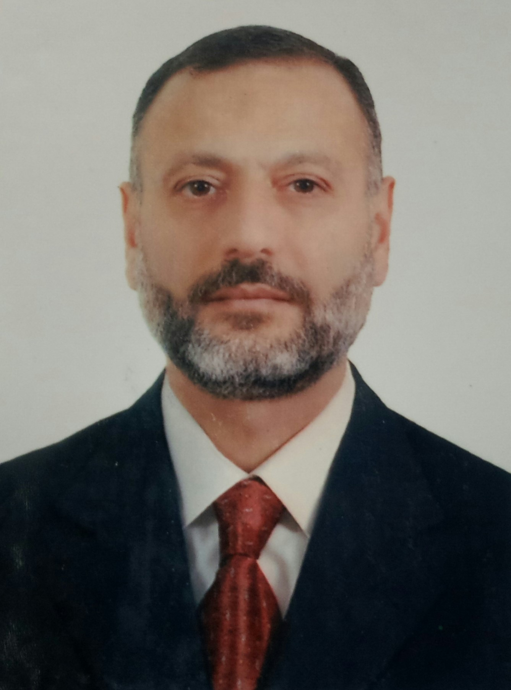
Name : Ali Abdul Hussein Muslim.
Date of birth :1964 – Baghdad
Nationality : Iraqi
Social life : Married
Sex : Male

Mob. / Iraq : +964 7902485457

E-mail : ali_muslem2003@yahoo.com

2-High Education:

Bachelor. Of Electrical Engineering – University of Technology / Baghdad
1986
Department : Electric power .

3-Profession Experience :

1. Iraqi Air Ways Co. (head of electric maintenance unit/maintenance
department) for the period 2006- present .
- Rehabilitation the control panels and electrical distribution boards of crafts
maintenance factories .
- Periodic maintenance for (L.V) & (M.V "11KV") substation .
- Periodic maintenance for standby generators (525KVA).
- All electric maintenance works for head office building of ( I,A,W)Co.(elevators ,pumps ,emergency lights fire alarm system & telephone network).
- Rehabilitation the ground power unit of crafts (400Hz,220V) .
- Rehabilitation the lighting of hangar (35m height).
- Maintain control panels of chillers & cooled water pumps .
- Maintain control panels of potable water pump station .
- Prepare (B.Q) for electric works in maintenance department & check electric
materials quality.
- Supervisor of Rehabilitation projects (catering building ,training center & cargo
stores).
- Management works & coordinating with related companies .

2. Al-ibticar Co. (supervisor for electric contracts & head of electric services
department for the period 2003 -2005.
- Executive Supervisor of electric power network. / Al-Karkh electricity office.
- Executive Supervisor of ( H.V 11 Kv ) electric power network . / Dora electricity office.
- Executive Supervisor of ( H.V 33 Kv ) electric power network . / Al-Karada electricity office.
- Director manager for electric works (new store project) /Iraqi national museum.
- Executive Supervisor of electric works (ministry of trading new building
project ) / Baghdad .
- Executive Supervisor of electric works Al-faiha hospital project / Basra.

3. Al-Mojam trading Co. (prepare offers & technical consultants) for the period from 2000 – 2003.

4. A.C.A.I. (Arab Co. for Antibiotic industries) / electrical services for (H.V.A.C. , power generators station , emergency light units ,water treatment station, sewage water pumping station and fire fighting station ) for the period 1998 –2000.
- Supervisor of control panel maintenance team.
- Supervisor of central control unit ( computerize ) of H.V.A.C . maintenance & operation team.
- Design & executive a control and observing system for air handling units (computerize ) .
- Design & executive an automatic control and protection unit for power substation.

5. Private sector ( design , manufacture & maintenance for control panels &
distribution boards ) from 1991-1998.

- Head of maintenance department / Al-Iraq factory for plastic industries.
- Design & install control panels and electrical distribution boards / Faris milling
factory.
- Design, manufacture & install control panels and electrical distribution boards
Haitham factory for plastic industries.
- Design, manufacture & install control panels / Modern factory for fine
founding.
- Rehabilitation control panels and electrical distribution boards / Al-Nuamania
factory for seeds.
- Head of design department / Baghdad factory for control panels.
- Supervisor of electric works for production lines / Karbala textile factory .

6. Al-Zawraa factory for control panels & distribution boards ( design ,
manufacture , installation ) for the period from 1987 – 1990.
- Design & supervision of manufacture the control panel of project ( 240 ) / ministry of military Industries .
- Design & supervision of manufacture the control panel of project (106 ) / ministry of military Industries .
- Design & supervision of manufacture the control panel of sponge factory /
chemical industries company.
- Design & supervision of manufacture a simulation panel for testing the control
Panels / Al-Zawraa factory.
- Design & supervision of manufacture a simulation panel for testing special
electronic cards / Al-Zawraa factory.
- Supervisor of installation the control panels & the measurement instruments of
project ( 410 ) / ministry of military Industries .
.
4-Technical Courses:

1- One month training in Westinghouse Fanal co. for control panels – Germany.
The training include :
- Design control panels .
- Manufacture control panels.
- Test control panels with electronic equipments.
- Install control panels in projects.
- Maintain control panels.

2-Three months training in salahddin establishment for electronic industries, the
training include:
- Design electronic cards .
- Design electronic testing units .
- Quality control of electronic units .
- Test the performance of electronic units .

3- One week training in professional safety .

4- Seminar about power transformer / Baghdad electricity office.

5- Computer skills:
- Windows programs.
- Internet.
- Industries programs such as (Johnson Control).
6- Certificates:

